2025 Bachelor’s Graduation Thesis

Development of a CAM System for Incremental Forming of CFRTP from 3D CAD Data

Precision Engineering Research Group
Green Engineering and Applied Sciences Course
Faculty of Science and Technology
Sophia University

A2177802
Karter Wong

Guidance Professor Hidetake Tanaka
Submitted on 17 July 2022

Table of Contents
Chapter 1: Introduction 5
1.1 Background information: Incremental Forming 5
1.1.1 Development History 5
1.1.2 Types of Incremental Forming 5
Single Point Incremental Forming (SPIF): 6
1.1.3 Current and Potential Applications for Incremental Forming 6
1.2 NC Machine Tools 9
1.2.1 Overview 9
1.2.2 NC program, G-Code, and Functions 9
1.2.3 3D CAD 9
1.2.4 CAM 10
1.2.5 Python 10
1.2.6 Toolpath 11
1.3 CFRP (Carbon Fiber Reinforced Plastic) 11
1.3.1 Overview 11
1.3.2 Classification and Characteristics of CFRP 12
1.4 Previous Research A 12
1.4.1 Overview 12
1.4.2 CAM System and Design of the Test Shape 12
1.4.3 Experimental Equipment 13
1.4.4 Results 13
1.4.5 Conclusions 14
1.5 Current Research Objectives 14
Chapter 2: Toolpath Generation 15
2.1 Program Overview 15
2.2 Libraries and Variables 15
2.3 Modules 17
Loading STL File and Extracting Point Cloud 17
Filtering Close Points to Prevent Clustering 18
Sorting Points to Prevent Doubling Back 18
Smoothing Hull Points 19
Applying Reverse Offset 20
2.4 Toolpath Generation Process 21
Main Toolpath Generation Loop 21
2.6 G-Code Generation and Export 24
2.7 NC Viewer Confirmation 27
Chapter 3: Incremental Forming Experiment and Evaluation 28
3.1 Introduction 28
Experimental Equipment 28
Machining Center 29
Discontinuous CFRTP 29
Oil Bath 30
Type of Oil 30
Forming tool 31
Aluminum and Carbon Fiber molds 31
Jig Dimensions 32
Test shape 33
3.3 Experimental Setup and Procedure 33
3.4 Experimental Results 34
CAM System Comparison 34
Incremental Forming Experiments 34
3.5 Evaluation 36
Chapter 5: Conclusion and Future Improvements 37
Appendix 38
Chapter 6: References 52

Chapter 1: Introduction

1.1 Background information: Incremental Forming
The increasing demand for lightweight, durable, and reusable materials in modern products has highlighted Carbon Fiber Reinforced Plastics (CFRP)due to its high strength-to-weight ratio and excellent mechanical properties [10]. Traditional molding techniques, while efficient for high-volume production, are too costly for low-volume and complex-designed products [2]. The low volume production, in addition to the mold costs, increases manufacturing and consumer costs, limiting accessibility. Dieless forming methods, such as 3D printing and incremental forming, offer a potential solution to produce low-volume products by eliminating the need for molds while allowing for the manufacturing of complex shapes [2]. The exceptional properties of CFRP make it challenging to manufacture products using innovative techniques, such as incremental forming, to address the challenges of manufacturing low-volume, high-mix production [2].

1.1.1 Development History
Incremental forming, pioneered in Japan during the 1990s by researchers such as Matsubara [14], is a dieless manufacturing technique designed for low-volume, complex components. Unlike traditional molding, it deforms materials through localized, incremental tool movements, offering flexibility for prototyping and custom production [2]. The process encompasses a variety of different techniques and methods, but the key characteristics of this type of manufacturing technology include:
- High geometric flexibility for complex shapes
- Elimination of dedicated molds
- Suitability for thin-shell structures
- Enhanced forming limits for sheet materials
- Cost-effective production for low-demand components

1.1.2 Types of Incremental Forming
There are many types of incremental forming; however, most are categorized into three main categories: Single Point Incremental Forming (SPIF), Two Point Incremental Forming (TPIF), and Double-Sided Incremental Forming (DSIF). For this research paper, single-point incremental forming was employed; therefore, two-point and double-sided incremental forming will not be discussed in the following sections as they are not relevant to the research paper.

Single Point Incremental Forming (SPIF):
Single-point incremental forming is the most straightforward and economical variant, where a tool deforms the sheet incrementally without the need for a mold. A backing plate often supports the workpiece or sheet of material. The process is highly flexible, allowing for rapid prototyping and low-volume production, as it can be executed on conventional CNC machines without the need for hydraulic presses. SPIF is ideal for creating parts directly from CAD models, eliminating the need for male or female dies. However, it may suffer from reduced accuracy due to springback and longer forming times. Applications include prototyping and small-batch production, with studies highlighting its increased formability but lower final accuracy [2].
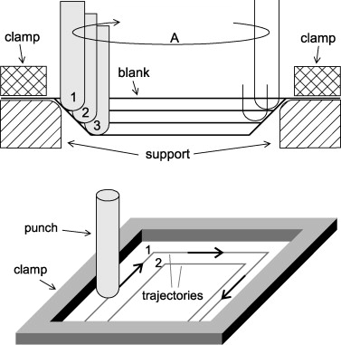
Figure 1: Principle of Single Point Incremental forming [Iseki et al., 1989].

Shot-Peen Incremental Forming

1.1.3 Current and Potential Applications for Incremental Forming
Incremental forming's ability to efficiently and cost-effectively manufacture complex shell shapes makes it ideal for low-volume, high-mix manufacturing, particularly in prototyping, custom component production, and material testing [2]. By eliminating the need for dedicated molds, incremental forming reduces setup costs and lead times, enabling rapid production and customization across various industries. Its ability to produce complex shapes with high forming limits enables incremental forming as a solution for applications requiring lightweight, durable components, especially when using advanced materials like Carbon Fiber Reinforced Thermoplastics (CFRTP) [2].
The broad applications of incremental forming underscore its potential to change the way we manufacture products on a large scale, particularly for components made from materials that are harder to manufacture with traditional methods. By enabling the cost-effective production of complex, lightweight parts, the technique supports sustainability goals across various industries, aligning with global trends toward reduced emissions and increased resource efficiency [15].

Automotive Industry
In the automotive sector, incremental forming has seen an increase in adaptation for low-volume production of complex, lightweight components, aligning with the industry's shift toward sustainable and efficient manufacturing [6]. For example, Toyota Motor Corporation utilizes static incremental forming to fabricate the front bumper of the Lexus LC Edge, achieving precise shaping without the use of molds, which reduces production costs by approximately 30% compared to traditional molding for low-volume runs [6]. The bumper, constructed from discontinuous CFRTP, leverages the high press formability to achieve a smooth surface and dimensional accuracy of ±0.1 mm [6]. Similarly, Ford utilizes incremental forming for custom interior panels in the Mustang Mach-E electric vehicle, enabling the rapid prototyping of lightweight dashboard components with complex curvatures and reducing the component's weight by 15% compared to aluminum alternatives [6]. Nissan applies the technique for structural components in the Leaf electric vehicle, such as battery enclosure supports, which benefit from CFRTP's vibration absorption and corrosion resistance, enhancing vehicle range by 5% through weight reduction [6]. These applications demonstrate the incremental forming process's ability to meet stringent automotive requirements for weight, strength, and cost efficiency.

Figure 2: Incremental Forming Application in Lexus LC Edge Front Bumper [Toyota Motor Corporation, 2020].

Aerospace Industry

In the aerospace sector, SPIF is employed for prototyping and fabricating lightweight, high-strength components that can also reduce the vibration in aircraft and complex structural parts. Incremental forming's ability to machine materials such as titanium and aluminum alloys, which are prevalent in the aerospace industry, makes it suitable for producing parts with strict performance requirements. Studies suggest that SPIF has the potential to form intricate aerospace components, such as wing parts or fuselage sections, contributing to weight reduction and improved fuel efficiency in aircraft design [15]. These applications highlight the potential for SPIF to be used in the aerospace industry.

Medical Applications
SPIF is utilized in the medical field for the manufacturing of customized implants, including cranial and craniofacial implants, where precision is critical. SPIF enables the creation of complex, patient-specific geometries using materials such as titanium. A study by Duflou et al. (2013) demonstrated the application of SPIF in producing accurate titanium craniofacial implants with high forming angles, meeting medical standards for fit and functionality [2]. Other research has explored SPIF for thin-shell clavicle implants, highlighting the versatility of SPIF in medical device manufacturing [4]. The capabilities of SPIF improve outcomes for patients in reconstructive and orthopedic surgeries. SPIF's precision and material versatility make it a critical tool in advancing medical device manufacturing.

1.2 NC Machine Tools

1.2.1 Overview
Numerical Control (NC) machines execute automated operations via programmed numerical commands, controlling tool position, speed, and operations with high precision [9]. Unlike manual processes, NC automation reduces processing times, enhances productivity, and lowers labor costs. Computer Numerical Control, or CNC, is an advanced form of numerical control that utilizes computer systems to manufacture products accurately, making it a prevalent technology in modern manufacturing [9].

1.2.2 NC program, G-Code, and Functions
An NC program automates CNC machine operations through blocks of code, such as:
G01 X8 Y10 Z9;
Each block comprises a preparatory function section (e.g., G01 for linear interpolation) and a coordinate section (e.g., X8 Y10 Z9 for tool position). Codes that start with the letter “G” serve as preparatory functions, M-codes handle miscellaneous functions (e.g., spindle start/stop), F-codes set feed rates, and S-codes control spindle speed [9]. Table 1 lists the functions used in this research.
Table 1: G-Code Functions for Incremental Forming
G-Code | Positioning | G00
G-Code | Linear Interpolation | G01
G-Code | mm input | G21
G-Code | Absolute coordinate command | G90
G-Code | Relative coordinate command | G91
G-Code | Work coordinate system settings. | G92
M Code | Spindle section | M03
M Code | Program end | M30
F Code | Feed Speed (mm/min) | F1000
S Code | Rotation Speed (RPM) | S500

1.2.3 3D CAD
Computer-Aided Design (CAD) software enables precise digital design of components [7]. Unlike 2D CAD, 3D CAD, such as Creo Parametric 4.0 used in this study, supports complex geometries and prototyping, reducing production errors by enabling the accurate generation of STL files for toolpath creation [7]. All test pieces and molds in this research were designed using 3D CAD to ensure precision in incremental forming.
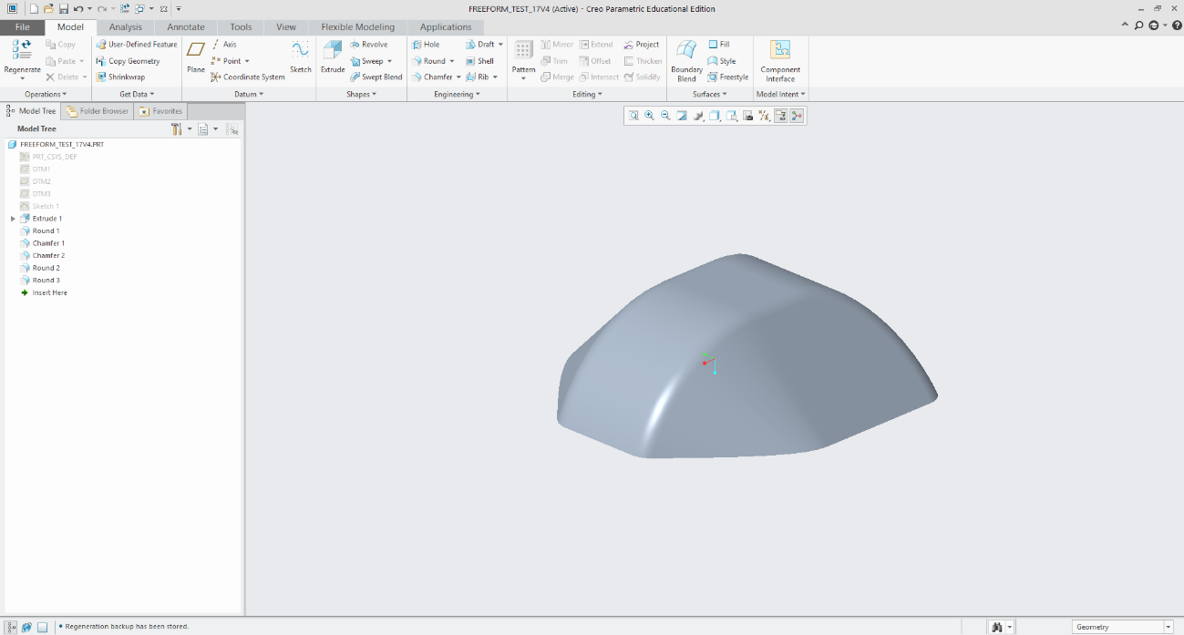
Figure 3: 3D CAD Model of Test Piece Designed in Creo Parametric [Wong, 2025].

1.2.4 CAM
Computer-aided manufacturing (CAM) systems utilize software and computer-controlled machinery to automate the manufacturing process. CAM systems are used to generate machining programs for CNC machines, automating the creation of toolpaths and reducing errors [7]. By simulating the generated toolpaths before forming, issues on the toolpath can be identified and fixed before manufacturing, significantly lowering production time and costs [7]. In this study, the CAM system processes STL files from Creo Parametric to produce the NC program for incremental forming.

G90 ; (Absolute positioning)
G21 ; (Set units to millimeters)
G92 X0.0 Y0.0 Z0 ; (Set workpiece origin)
F1000 ; (Set feed rate)
G01 X0.0 Y0.0 Z20 ; (Move to safe height)

Figure 4: Sample NC program for Incremental Forming [Wong, 2025].

1.2.5 Python
Python, an open-source programming language, is renowned for its simplicity, and its libraries enable programmers to develop complex programs efficiently [3]. Libraries such as NumPy, Pandas, and PyVista can efficiently process large amounts of data, making Python an ideal choice for developing CAM systems [3]. In this study, Python was selected for its readability and ability to process STL files and generate optimized G-code toolpaths for incremental forming.

1.2.6 Toolpath
A tool path is the path along which a machining tool moves. A tool path is created using the 3D coordinates of an STL file from CAD software to collect all the points, forming a point cloud from the triangles of the STL file. From this, the points are sorted, duplicate points are deleted, a set of coordinates is generated, and then the necessary pieces are added to convert the coordinates into the NC program. The NC program can instruct the tool on the machining path. The toolpath was viewed using an NC viewer web browser to identify potential issues before manufacturing.
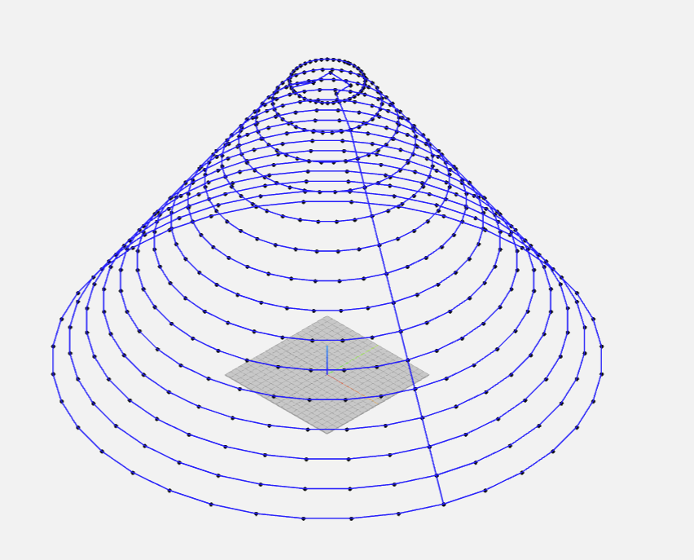
Figure 5: Toolpath Visualization for Truncated Cone [Wong, 2025].

1.3 CFRP (Carbon Fiber Reinforced Plastic)

1.3.1 Overview
Carbon Fiber Reinforced Plastics (CFRP) combine carbon fibers with a polymer matrix to achieve superior mechanical properties, including a specific strength up to 10 times that of iron and a specific gravity of 1.8 g/cm³, which is significantly lower than that of aluminum 2.7 g/cm³ [10]. CFRP's high strength-to-weight ratio, vibration absorption, and corrosion resistance make it ideal for use in various industries that emphasize the use of lightweight and durable materials, such as aerospace, automotive, sports equipment, and medical devices [10].

1.3.2 Classification and Characteristics of CFRP
CFRP is categorized by matrix type and fiber orientation, influencing its mechanical properties and applications [10]. The four main properties are Thermosetting (CFRTS): Thermoplastic (CFRTP), continuous fiber, and discontinuous fiber CFRP. CFRTS is characterized by a high specific strength and heat resistance. However, it requires long molding times and is non-recyclable [10]. CFRTS is used in the aerospace industry and sports equipment. CFRTP offers lower specific strength and heat resistance but enables shorter molding times, lower costs, and partial recyclability [10]. Continuous Fiber CFRTP features a layered structure with aligned fibers, providing high specific strength but limited formability [10]. Discontinuous Fiber CFRTP features a random fiber
orientation, providing isotropic strength and high press formability, which makes it ideal for complex shapes despite its lower overall strength [10].

1.4 Previous Research A

1.4.1 Overview
In this previous research, the researcher developed a Python-based CAM system for static incremental forming of discontinuous fiber CFRTP, utilizing an oil bath for material heating to enable dieless forming. The system generates NC program toolpaths from CAD models, addressing the high costs and inflexibility of traditional molding for low-volume, thin-shell components [5].

1.4.2 CAM System and Design of the Test Shape
The CAM system achieves three goals: reading an STL file from Creo Parametric 4.0, extracting the 3D point clouds of the target shapes, and creating a tool path in G-code [5]. The code utilizes Python libraries to generate a point cloud from the STL file. It converts the clouds into layers by Z-height and connects the points in each layer by the minimum Euclidean distance. Finally, it takes the coordinates and adds the proper syntax for use by the CNC machines. The shape created in Creo was a truncated cone with varying dimensions. The radius of the shape ranges from 20 mm to 40 mm, and similarly, the wall angle is 30°, 40°, and 50°. The pitch or resolution of the STL is 1. The dimensions were selected to match the working area and limitations of the experimental setup. The shape was chosen because it is suitable for proof of concept, especially for plastic deformation layering [5].

1.4.3 Experimental Equipment
The experimental setup for this research is summarized in Table 2, with most equipment reused for consistency and reproducibility.
Table 2: Experimental Equipment Specifications
Equipment | Description | Specification
CFRTP Sheet | PA6 matrix, 20 wt% carbon fiber | 110 mm × 110 mm × 1 mm
Oil Bath | T-22H (Thomas Scientific) | Up to 200°C, ±0.2°C precision, jet circulation
Silicone Oil | KF968 (Shin-Etsu) | Non-volatile, stable to 250°C, fire-resistant
CNC Machine | Sodick MC430L | X 420 mm, Y 350 mm, Z 200 mm, feed up to 36 m/min
Tool (Mandrel) | SUS304 | 5 mm diameter, 2.5 mm radius tip, 60 mm length
Jig | Custom design | Submerged in oil bath, secure clamping, detachable

1.4.4 Results
The experiments identified key parameters that influence the success of incremental forming, including material temperature, tool rotation, wall angle, and radius [5].
Temperature Effects
Optimal forming occurred at 180–200°C (453–473 K), achieving smooth surfaces and minimal defects. Below 160°C (433 K), insufficient softening led to cracks, with a minimum forming temperature of 50°C (323 K) [5].
Tool Rotation
A spindle speed of 1000 rpm enhanced forming depth (up to 14.9 mm) and surface smoothness (Ra < 2 µm), reducing uneven wall thickness compared to non-rotating conditions [5].
Wall Angle
Wall angles of 30° and 40° yielded smooth forming with minimal springback (< 5%). Angles near 40° exhibited minor deformations, while angles greater than or equal to 50° were at risk of cracking due to excessive stress [5].
Radius Variations
Smaller radii (20 mm) achieved deeper forming (14.9 mm) but increased wall stress (up to 300 MPa), while larger radii (40 mm) produced shallower forms (8 mm) with uniform wall strength [5].
Table 3: Forming Criteria Summary
Condition | Depth (mm) | Temperature (°C) | Radius (mm) | Wall Angle (°) | Spindle Speed (rpm)
Maximum | 14.9 | 200 | 20 | 40 | 1000
Minimum | 3.6 | 160 | 40 | 50 | 0

1.4.5 Conclusions
Previous research [5] developed a Python-based CAM system that effectively generates toolpaths from STL data for use in static incremental forming of discontinuous CFRTP. By leveraging Python libraries such as PyVista, Pandas, and NumPy, the CAM system extracted a 3D point cloud, sorted them by Z-height, and connected points using a nearest-neighbor algorithm, enabling flexible production of complex shapes for low-volume applications [5]. This approach to creating a toolpath enables the CAM system to be compatible with any CAD software that can produce STL files, thereby streamlining the process from design to manufacturing. However, the CAM system itself has several limitations, preventing it from handling complex geometries and is susceptible to toolpath errors, such as creating a "messy" toolpath that moves the tool to unnecessary points.
During the incremental forming experiments, it was found that wall angles of 50° or greater had a higher chance of breaking the test piece [5]. The Author of previous research A highlighted some challenges for future experiments, namely the issue of springback shape distortion and the need for advanced evaluation methods, suggesting that including scribed circle tests and 3D scanning with Einscan-SE might help with analyzing the formed shape [5].

1.5 Current Research Objectives
This study aims to enhance the CAM system by building upon previous research, as outlined in the appendix. The primary areas of focus for the CAM system are its ability to produce precise, error-free toolpaths for the static incremental forming of discontinuous CFRTP, the speed at which the program can output the Toolpath, and streamlining the process from design to manufacturing. To evaluate the CAM system’s ability to generate an error-free toolpath, the Toolpath's performance will be first presented in an NC viewer to confirm a clean toolpath and then tested using a Sodick MC430L CNC machining center in controlled heating conditions, with an oil bath at 120°C. The research will utilize the CAM system from previous research as a baseline for the new complex test shape, which will be presented later in the paper.

Chapter 2: Toolpath Generation

2.1 Program Overview
This chapter describes the changes and overall flow of the updated CAM system, based on previous research, to enable the system to support complex geometries. The updated CAM system’s overall workflow is similar to that of the previous CAM system; it takes STL data from CAD software, generates a toolpath, and converts it to G-code for CNC machining [5]. The updated workflow introduces a step where all the logic for making the Toolpath is done. The entire CAM system is outlined in Section A1 of the appendix.
Figure 6: CAM System Workflow for Toolpath Generation [Wong, 2025].

2.2 Libraries and Variables

Libraries
Python libraries are collections of pre-written code that provide reusable functions and tools to simplify programming tasks. Libraries help optimize code that is used for computational problem-solving, simulations, and optimization [3]. Python offers an extensive library and the ability for third-party programmers to create libraries that are made publicly available.
The updated CAM system uses several libraries to optimize the Toolpath's generation.
- Pandas: This library is primarily utilized for data manipulation and storage. Pandas provides the `DataFrame` structure, which can store point cloud data extracted from STL files. Its ability to manage large datasets efficiently is crucial for processing the hundreds of thousands of points typically generated from 3D models [3].
- NumPy: Numpy can do high-performance numerical operations, including array manipulations and linear algebra functions. NumPy's efficiency is crucial for handling the computational demands of toolpath generation, ion as it can calculate the distances between points [3].
- SciPy (ConvexHull): The `ConvexHull` module from SciPy computes the convex hull of 2D point sets. It identifies the outermost points of each layer to define the toolpath boundary [3]. The function of the library ensures that only the external contour of the shape is machined, reducing unnecessary tool movements.
- STL (numpy-stl): The `mesh` module from the `numpy-stl` library reads STL files, extracting the point's coordinates to form the point cloud used for toolpath generation [7]. STL files are standard in CAD systems for representing 3D geometries as triangular meshes.

Variables
The previous CAM system also had variables. However, their primary function was to store values for the toolpath generation. In the updated CAM system, several variables were added to allow the operator to adjust the values according to the shape being created easily. The following variables are important to change depending on the test shape.
- TOOL_DIAMETER: The tool diameter variable, as the name suggests, is the diameter of the forming tool. This parameter is used to calculate the offsets, ensuring the tool's geometry is accounted for during forming [5]. The use of diameter is for simplicity, as the program can halve the value for the radius.
- Z_SPRINGBACK_OFFSET: When conducting incremental forming without a mold, the material often rebounds slightly; this phenomenon is called springback [12]. This variable typically has a negative value, which shifts the Z-coordinates down, thereby ensuring that the shape is machined correctly.
- LAYER_THICKNESS: During the incremental forming process, it is important to maintain uniform layer thicknesses. Uniform layer distances will improve the formability of the formed shape, this variable defines the vertical distance between layers, controlling the resolution of the Toolpath along the Z-axis. Uniform layer spacing ensures consistent forming depth [5].
- MIN_DISTANCE: The minimum distance variable is used to prevent clusters of points from forming along the Toolpath. This ensures that the Toolpath is smooth and prevents unnecessary tool movements [5].
- Z_OFFSET: This offset adjusts the Z-coordinate of the entire Toolpath to align with the CNC machine's workspace, ensuring the tool operates within the safe working area [9].
- SAFE_Z_RELATIVE: This variable specifies the height to which the tool retracts after forming, preventing collisions during tool withdrawal that might damage the machined shape [9].

2.3 Modules
The majority of the changes made to the CAM system are located in the setup of variables, libraries, and logic section of Figure 6. In that section, the code can be broken down into several subsections or modules. The modules are designed in this way so that the points are in a refined state before being run through the main toolpath loop or setting up the logic to be used in the main toolpath loop.

Loading STL File and Extracting Point Cloud
def load_stl_to_dataframe(stl_file, layer_thickness=1.0):
stl_mesh = mesh.Mesh.from_file(stl_file)
vertices = stl_mesh.vectors.reshape(-1, 3)
df = pd.DataFrame(vertices, columns=['x', 'y', 'z'])
df = df.drop_duplicates().reset_index(drop=True)
df['z'] = np.round(df['z'] / layer_thickness) * layer_thickness
return df.dropna()
Figure 7: Code to load an STL and create a point cloud.
This module reads the STL file and converts its vertices into a structured point cloud, assigning them Cartesian coordinates (X, Y, and Z) for toolpath generation. The module then edits the point cloud to ensure that the layers grouped by the Z coordinate are equidistant to each other. The code accomplishes this by rounding the Z coordinate value to the nearest multiple of the layer thickness that was previously set. The module then removes duplicate points and incomplete coordinates to enhance computational efficiency and toolpath accuracy, which is key when processing complex geometries [5]. Then, the points are saved into a data frame for later use.

Filtering Close Points to Prevent Clustering
def filter_close_points(points, min_distance=0.5):
filtered = [points[0]]
for p in points[1:]:
if np.linalg.norm(p - filtered[-1]) >= min_distance:
filtered.append(p)
return np.array(filtered)
Figure 8: Code for Preventing Point Clustering on the Toolpath
This module sets up some logic to be used in the main toolpath generation loop. The module reduces the point density in the point cloud to remove clusters of points, which could lead to inefficient toolpaths or machining errors. The module accomplishes this by loading the points output from the previous module, calculating the distance from the initial point in the list of points, and removing any point that exceeds the min_distance value. The filtered points are returned as a NumPy array, preserving only points that are spaced apart. By enforcing a minimum distance, this function optimizes the Toolpath, reducing machining time while also reducing errors.

Sorting Points to Prevent Doubling Back
def sort_points_no_overlap(points):
center = points.mean(axis=0)
angles = np.arctan2(points[:, 1] - center[1], points[:, 0] - center[0])
sorted_indices = np.argsort(angles)
sorted_points = points[sorted_indices]
n = len(sorted_points)
for i in range(n):
p1, p2 = sorted_points[i], sorted_points[(i + 1) % n]
for j in range(i + 2, n):
p3, p4 = sorted_points[j], sorted_points[(j + 1) % n]
if intersects(p1, p2, p3, p4):
sorted_points[i + 1:j + 1] = sorted_points[i + 1:j + 1][::-1]
return sorted_points
Figure 9: The Code for Sorting Points to Prevent Doubling Back in the Toolpath

def intersects(p1, p2, p3, p4):
def ccw(A, B, C):
return (C[1] - A[1]) * (B[0] - A[0]) > (B[1] - A[1]) * (C[0] - A[0])
return ccw(p1, p3, p4) != ccw(p2, p3, p4) and ccw(p1, p2, p3) != ccw(p1, p2, p4)
Figure 10: Line Segment Intersection Check
This module sorts points in each layer to create a non-overlapping, clockwise toolpath, minimizing travel distance and preventing toolpath intersections. The module calculates the mean of the points and determines the centroid of the layer. The layer's centroid then serves as a reference for calculating the angles of each point. The module sorts the points by these angles, reversing the order of points if there are any intersections between the lines it temporarily creates to prevent doubling back.
The sorting algorithm, inspired by a simplified Traveling Salesperson Problem (TSP) approach, ensures an efficient and non-overlapping toolpath, which is critical for smooth CNC operation and high-quality surface finishes [3]. By preventing doubling back, it reduces machining time and mitigates risks of toolpath errors, aligning with the research's goal of optimizing toolpath generation for complex CFRTP shapes [5].

Smoothing Hull Points
def smooth_hull_points(points, alpha=0.3):
smoothed = points.copy()
for i in range(len(points)):
prev = points[(i - 1) % len(points)]
next = points[(i + 1) % len(points)]
smoothed[i] = (1 - alpha) * points[i] + alpha * (prev + next) / 2
return smoothed
Figure 11: Smoothing of the Toolpath
To ensure a smooth machining process, this module is applied to points that are run through the convex hull function and the reverse offset module, reducing sharp transitions and improving toolpath continuity. The module creates a copy of the points it is given and then computes a weighted average using the current point and the average of the neighboring points. The `alpha` parameter controls the smoothing intensity, balancing the original point's position with the influence of its neighbors. Then, the module ensures that the points are continuous and finally returns the points to the Toolpath.
Sharp transitions in the Toolpath can cause abrupt tool movements, leading to material fractures or tool vibrations. The smoothing module enhances the toolpath quality, ensuring uniform deformation.

Applying Reverse Offset
def reverse_offset(points, TOOL_DIAMETER=2.5, z_springback_offset=-0.1):
adjusted_points = points.copy()
center = points[:, :2].mean(axis=0)
distances = np.linalg.norm(points[:, :2] - center, axis=1)
layer_radius = distances.max() if distances.size > 0 else 1.0
print(f"Layer at Z={points[0, 2]:.2f}, points={len(points)}, radius={layer_radius:.2f} mm, TOOL_DIAMETER={TOOL_DIAMETER:.2f} mm")
for i, point in enumerate(adjusted_points):
direction = point[:2] - center
norm = np.linalg.norm(direction)
if norm > 1e-6:
direction /= norm
offset = TOOL_DIAMETER * direction
adjusted_points[i, :2] -= offset
print(f"Point {i}: Offset applied = {offset[0]:.2f}, {offset[1]:.2f}")
adjusted_points[i, 2] += z_springback_offset
adjusted_points[:, :2] = smooth_hull_points(adjusted_points[:, :2])
x_min, x_max = adjusted_points[:, 0].min(), adjusted_points[:, 0].max()
y_min, y_max = adjusted_points[:, 1].min(), adjusted_points[:, 1].max()
adj_distances = np.linalg.norm(adjusted_points[:, :2] - center, axis=1)
adj_layer_radius = adj_distances.max() if adj_distances.size > 0 else 1.0
print(f"Adjusted radius={adj_layer_radius:.2f} mm")
print(f"Bounding box: X=[{x_min:.2f}, {x_max:.2f}], Y=[{y_min:.2f}, {y_max:.2f}]")
return adjusted_points
Figure 12: Reverse Offset Logic
The reverse offset module adjusts the Toolpath to account for the tool's geometry and material springback, ensuring accurate forming. During this process, the centroid of each layer is calculated from the points being processed in the main toolpath generation loop, defining the layer's shape. Then, the tool diameter and z_springback_offset values are applied to the points on the Toolpath to ensure that the machined shape is accurate. Finally, the adjusted 3D points are returned, incorporating the offset and smoothing.

2.4 Toolpath Generation Process

Main Toolpath Generation Loop
ll = []
prev_exit_point = None
z_levels = sorted(df['z'].unique(), reverse=True)
if len(z_levels) > 1:
z_diffs = [z_levels[i] - z_levels[i + 1] for i in range(len(z_levels) - 1)]
avg_spacing = np.mean(z_diffs)
print(f"Average layer spacing in input data: {avg_spacing:.3f} mm")
else:
avg_spacing = 1
print("Only one Z level in input data, using default spacing of 1 mm")
uniform_z_levels = []
start_z = z_levels[0]
for i in range(len(z_levels)):
new_z = start_z - i * avg_spacing
uniform_z_levels.append(new_z)
center_x, center_y = None, None
for layer_idx, current_layer_z in enumerate(z_levels):
current_layer = df[df['z'] == current_layer_z][['x', 'y', 'z']].values
if len(current_layer) >= 5:
center_x, center_y = current_layer[:, :2].mean(axis=0)
break
if center_x is None or center_y is None:
print("Warning: Could not compute center from any layer. Using (0, 0) as fallback.")
center_x, center_y = 0.0, 0.0
for layer_idx, current_layer_z in enumerate(z_levels):
current_layer = df[df['z'] == current_layer_z][['x', 'y', 'z']].values
if len(current_layer) < 5:
print(f"Skipping layer at Z={current_layer_z:.2f} due to insufficient points ({len(current_layer)})")
continue
layer_points_2d = current_layer[:, :2]
try:
hull = ConvexHull(layer_points_2d)
hull_coords = layer_points_2d[hull.vertices]
except Exception as e:
print(f"Skipping layer at Z={current_layer_z:.2f} due to hull error: {str(e)})")
continue
if hull_coords.shape[0] < 5:
print(f"Skipping layer at Z={current_layer_z:.6f} due to insufficient hull vertices ({hull_coords.shape[0]})")
continue
hull_coords = filter_close_points(hull_coords, min_distance=MIN_DISTANCE)
hull_z = np.full((hull_coords.shape[0], 1), uniform_z_levels[layer_idx])
hull_points_3d = np.hstack([hull_coords, hull_z])
adjusted_points_3d = reverse_offset(hull_points_3d, TOOL_DIAMETER=TOOL_DIAMETER, z_springback_offset=Z_SPRINGBACK_OFFSET)
adjusted_points_2d = adjusted_points_3d[:, :2]
sorted_points = sort_points_no_overlap(adjusted_points_2d)
if layer_idx == 0:
centroid = np.array([center_x, center_y])
dists = np.linalg.norm(sorted_points - centroid, axis=1)
start_idx = np.argmin(dists)
sorted_points = np.roll(sorted_points, -start_idx, axis=0)
elif prev_exit_point is not None:
dists = np.linalg.norm(sorted_points - prev_exit_point[:2], axis=1)
start_idx = np.argmin(dists)
sorted_points = np.roll(sorted_points, -start_idx, axis=0)
sorted_layer = np.hstack([sorted_points, np.full((sorted_points.shape[0], 1), adjusted_points_3d[0, 2])])
layer_path = list(sorted_layer)
layer_path.append(layer_path[0]) # Close the loop
ll.extend(layer_path)
prev_exit_point = layer_path[0]
if len(ll) == 0:
print("Warning: No toolpath points generated. Check input data or layer filtering.")
exit()
Figure 13: The Code for the Main Toolpath generation loop
The main loop integrates all previous functions to create a cohesive toolpath that can later be converted to G-code. The loop processes the point cloud by every Z-level or layer of the STL file to create a continuous toolpath. The loop begins by creating an empty list where the Toolpath will be stored after it is generated from the coordinates.
The loop will also keep track of the last point for smooth layer transitions and closing the layer. For the first layer in the shape, the point closest to the centroid is selected as the starting point. For the subsequent layers, the point that is closest to the last point of the previous layer is chosen. The loop starts processing the layers from top to bottom, mimicking the incremental forming process [2]. The loop calculates the centroid for the layer, using 5 points, to ensure sufficient data for the convex hull computation. Next, the convexhull identifies the outermost points of the 2D layer, defining the layer for machining [3]. After convexhull is applied, all the modules previously discussed, except for the STL loading and point cloud formation, are applied to the list.
Finally, the loop stores the processed layer in the list that it created at the beginning of the process, and the last point in the list is set as the first point for the next layer.
The use of uniform Z-levels and convex hulls ensures compatibility with CNC machining. At the same time, the selection of nearest-neighbor start points optimizes tool travel, reducing machining time and enhancing efficiency [3]. The robust error handling aligns with the research's emphasis on error-free toolpaths [2].

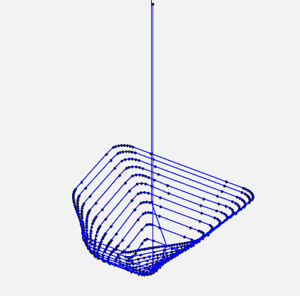
Figure 14: Toolpath Generation for Complex Shape [Wong, 2025].

2.6 G-Code Generation and Export
ll = np.array(ll)
ll[:, 2] -= Z_OFFSET
ll = np.round(ll, 2)
pd.DataFrame(ll, columns=['x', 'y', 'z']).to_csv('toolpath.csv', index=False)
df_ltp = pd.read_csv('toolpath.csv')
df_ltp['x'] = df_ltp['x'].round(2)
df_ltp['y'] = df_ltp['y'].round(2)
df_ltp['z'] = df_ltp['z'].round(2)
df_gchord = pd.DataFrame({
'G': 'G01',
'x': 'X' + df_ltp['x'].map('{:.2f}'.format),
'y': 'Y' + df_ltp['y'].map('{:.2f}'.format),
'z': 'Z' + df_ltp['z'].map('{:.2f}'.format),
'EOB': ';'
})
first_x = round(df_ltp.iloc[0]['x'], 2)
first_y = round(df_ltp.iloc[0]['y'], 2)
first_z = round(df_ltp.iloc[0]['z'], 2)
gcode_header = [
"G90 ; (Absolute positioning)",
"G21 ; (Set units to millimeters)",
"M03 ; (Start spindle)",
"S500 ; (Setting spindle speed)",
"F1000 ; (Set feedrate)",
f"G00 X{center_x:.2f} Y{center_y:.2f} ; (Rapid move to centroid)",
f "G01 Z{first_z:.2f} ; (Drop to first point's Z)",
f"G01 X{first_x:.2f} Y{first_y:.2f} ; (Move to first toolpath point)"
]
last_x = round(df_ltp.iloc[-1]['x'], 2)
last_y = round(df_ltp.iloc[-1]['y'], 2)
last_z = df_ltp.iloc[-1]['z']
final_safe_z = last_z + SAFE_Z_RELATIVE
gcode_footer = [
f"G01 X{last_x:.2f} Y{last_y:.2f} Z{final_safe_z:.2f} ; (Retract tool to safe Z)",
"M30 ; (End of program)"
]
with open('Gchord.txt', 'w') as f:
for line in gcode_header:
f.write(line + '\n')
df_gchord.to_csv(f, index=False, sep=" ", header=False, mode='a')
for line in gcode_footer:
f.write(line + '\n')
Figure 15: Coordinate points to G-code conversion
This final section of the code converts the coordinate points into the Toolpath by applying the G-code functions and exports it for CNC machining. First, the Z-coordinates are adjusted by subtracting the value of the Z_OFFSET variable to align the Toolpath with the CNC machine's workspace. The values are then rounded by two decimal places to increase the precision of the Toolpath. The list of coordinates is saved as a CSV file (`toolpath.csv`) for storage. A DataFrame is created with G-code commands, prefixed coordinates (`X,` `Y,` `Z`), and semicolons (`;`) as end-of-block markers are then combined with the coordinates to generate the Toolpath.
After this, a header and footer are added to the Toolpath with the G-code annotations ready for use in the CNC machine. The header and footer are shown in Figure 16 and Figure 17, respectively. The G-code conversion ensures compatibility with CNC machines, enabling automated incremental forming [9]. The header and footer streamline machine setup and shutdown, while the centroid-based initial move optimizes tool positioning, reducing setup time. The G-code conversion enables the improvement of the design-to-manufacturing process.[2].
G90: Sets absolute positioning.
G21: Uses millimeters as units.
M03: Starts the spindle.
S500: Sets spindle speed to 500 rpm, optimized for CFRTP forming [5].
F1000: Sets feed rate to 1000 mm/min.
f"G00 X{center_x:.2f} Y{center_y:.2f} ; (Rapid move to centroid)",
f"G01 Z{first_z:.2f} ; (Drop to first point's Z)",
f"G01 X{first_x:.2f} Y{first_y:.2f} ; (Move to first toolpath point)"
Figure 16: G-code Header
f"G01 X{last_x:.2f} Y{last_y:.2f} Z{final_safe_z:.2f} ; (Retract tool to safe Z)",
"M30 ; (End of program)"
Figure 17: G-code Footer
Finally, the file is exported to a text file titled `Gchord.txt` for direct CNC input.

2.7 NC Viewer Confirmation
To validate that there are no issues with the Toolpath, the website NCviewer.com is used to visualize the Toolpath and simulate the forming process. This extra step enables the operator to identify and address any potential issues that may arise before the manufacturing process begins.
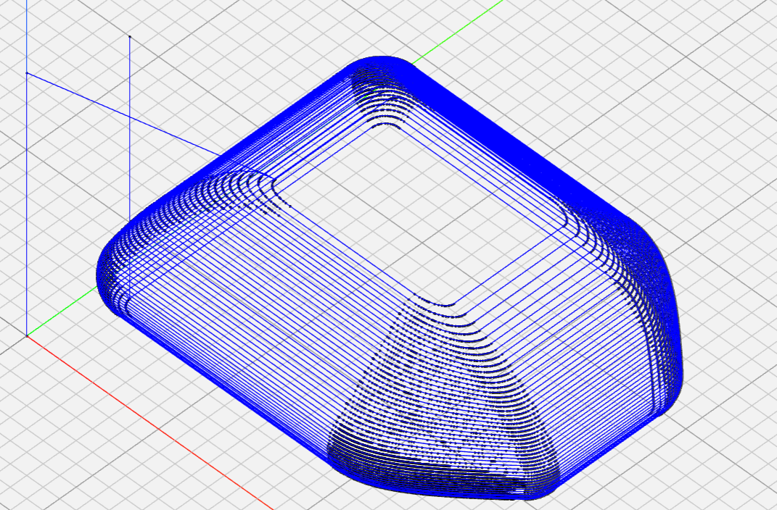
Figure 18: NC Toolpath Visualization [Wong, 2025].

Chapter 3: Incremental Forming Experiment and Evaluation

3.1 Introduction
As mentioned in Section 1.5 of this research paper, this study aims to enhance the CAM system by building upon previous research, which is outlined in the appendix. The main areas of focus for the CAM system are its ability to produce precise, error-free toolpaths for the incremental forming of discontinuous CFRTP with more complex geometries, the speed at which the program can output the Toolpath and streamlining the process from design to manufacturing. To evaluate the CAM system’s ability to generate an error-free toolpath, the Toolpath generated by the CAM system will be used on nylon sheets and discontinuous CFRTP.

Experimental Equipment
Much of the equipment used in this experiment will be the same as that used in previous research (A) and is summarized in Table 3.1 below.
Table 4: Experimental Equipment Specifications
Equipment | Description | Specification
CFRTP Sheet | PA6 matrix, 20 wt% carbon fiber | 110 mm × 110 mm × 1 mm, dried at 120°C for 24 h (ETTAS oven)
Oil Bath | T-22H (Thomas Scientific) | Up to 200°C, ±0.2°C precision, jet circulation
Silicone Oil | KF968 (Shin-Etsu) | Non-volatile, stable to 250°C, fire-resistant
CNC Machine | Sodick MC430L | X 420 mm, Y 350 mm, Z 200 mm, feed up to 36 m/min
Tool (Mandrel) | SUS304 | 5 mm diameter, 2.5 mm radius tip, 60 mm length
Jig | Custom design | Submerged in oil bath, secure clamping, detachable

Machining Center
The Sodick MC430L is a vertical precision linear machining center. The machining center can read the G-code toolpaths used in the tests. The machining center can move in three directions, X, Y, and Z, and features a tool clamp attached to the Z axis. The maximum travel distance of the machining center is 420 mm in the X direction, 350 mm in the Y direction, and 200 mm in the Z direction. The maximum federate or maximum speed that the machine center can move is 36 m/min, and the maximum spindle speed is 40,000 rpm.
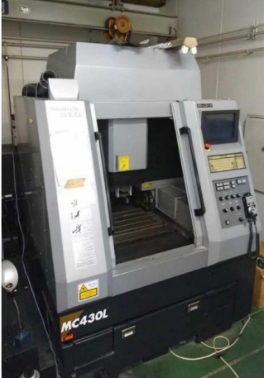
Figure 19: Appearance of MC430L

Discontinuous CFRTP
As mentioned in Section 1.3.4, discontinuous fiber CFRTP was selected as the testing material due to its short molding time, cost-effectiveness, and partial recyclability, making it suitable for the incremental forming of complex, low-volume components, which aligns with the research's focus on efficient toolpath generation. The CFRTP is composed of 20% carbon fiber, with the remaining 80% being a common thermoplastic known as nylon 6. The dimensions of the individual sheets are 110 mm × 110 mm × 1 mm. It was chosen for its isotropic strength, high formability under pressure, and cost-effectiveness [12].

Oil Bath
The T-22H oil bath provides uniform heating up to 200°C with a precision of ±0.2°C, can hold up to 21 liters of liquid, and measures 425 mm x 350 mm x 150 mm. This oil bath was used in this study to process the discontinuous fiber CFRTP above its glass transition temperature of ____; the sample is heated in the oil bath while being processed. The oil bath features a precise temperature control function, enabling the temperature to be maintained during the forming process. The oil bath is secured in the machining center to ensure the CFRTP remains soft during the forming process.
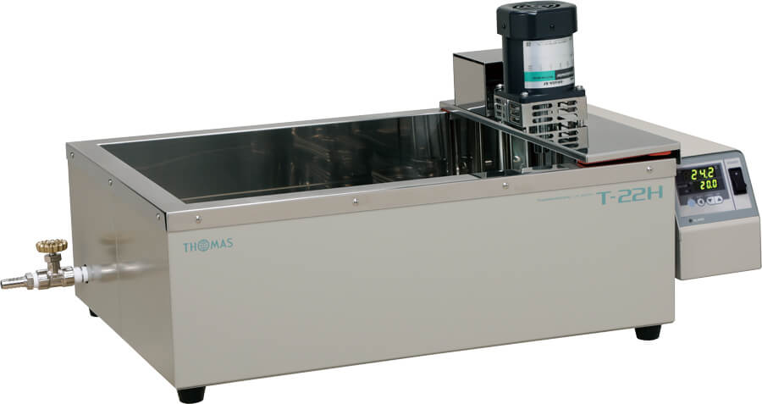
Figure 20: Appearance of T-22H [Wong, 2025]

Type of Oil
The oil used to heat the CFRTP is Shin-Etsu KF968 silicone oil due to its ability to retain high temperatures of up to 250°C. This is important because, during the tests, the temperatures at which the tests with CFRTP are conducted are 150 °C, which is well below the 250 °C limit. Alongside its temperature resistance, low volatility, and fire resistance, these factors contribute to why the oil was selected, ensuring safety and stability at temperatures ranging from 50 °C to 200°C (323–473 K) [5].


Figure 20: Shin-Etsu Chemical KF968 oil that is used. [Tanata, 2023]

Forming tool
A SUS304 mandrel (5 mm diameter, 2.5 mm radius tip, 60 mm length) was used as the forming tip for the experiments. The mandrel was secured to the machining center by a Mega Micro Type S Chuck. The Chuck allows the forming tool to remain steady, even when rotated at high speeds, enabling incremental forming to be performed at high rotations per minute.
Table 5: Mega Micro Type S Chuck Dimensions
Mega Micro type S Chuck
Ød : | 0.45 - 6.05
ØD: | 14 mm
L: | 45
L1: | 32
G: | -
H1: | 28
H2: | 31
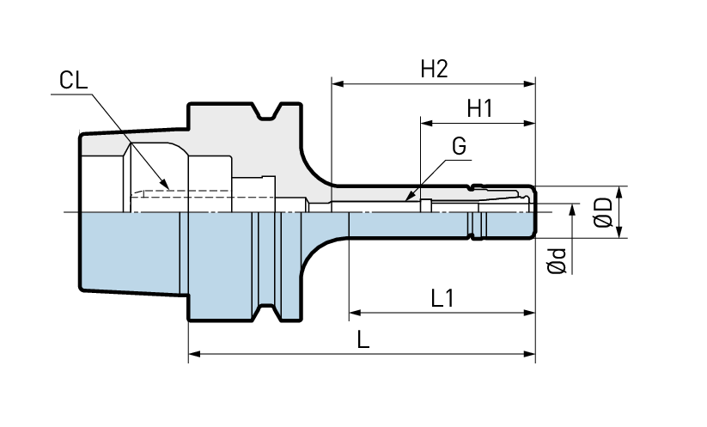
Figure 21: Mega Micro Type S Chuck Without the Tool [Big Daishowa]

Aluminum and Carbon Fiber molds
A 3D-printed mold, created using a Markforged II 3D printer, was utilized to test the feasibility of the CAM system's generated Toolpath using a nylon sheet before conducting the tests with CFRTP. The nylon sheet was chosen as it has similar properties to the CFRTP and was a less expensive material to test the Toolpath. The Aluminum mold was used for experiments with the CFRTP due to its ability to withstand the high temperatures required to bring the CFRTP into a malleable state.
Both the aluminum and carbon fiber molds are 89.92 mm x 89.92 mm x 20 mm in thickness, as shown in the technical drawing in the figure below.
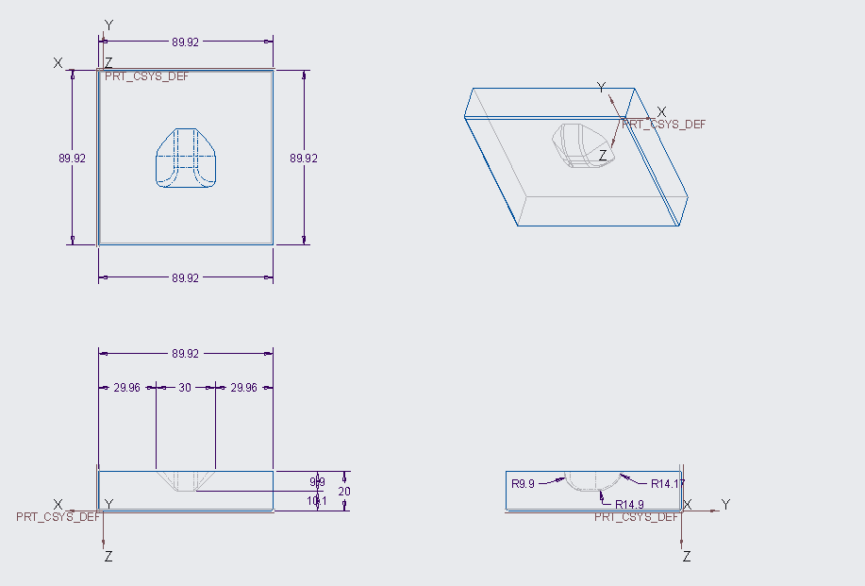
Figure 22: Isometric Drawing of the Molds used in the experiment [Wong, 2025]

Jig Dimensions
A custom jig was used to secure the CFRTP in place during the incremental forming process. The Jig is 190 mm x 190 mm, with a 90 mm x 90 mm square located in the middle of the Jig. This allows for a mold to be placed in the center if needed. The Jig also has a removable upper frame that secures CFRTP sheets during the forming process. The Jig can be used with or without a mold and with or without oil, as shown in the figures below.
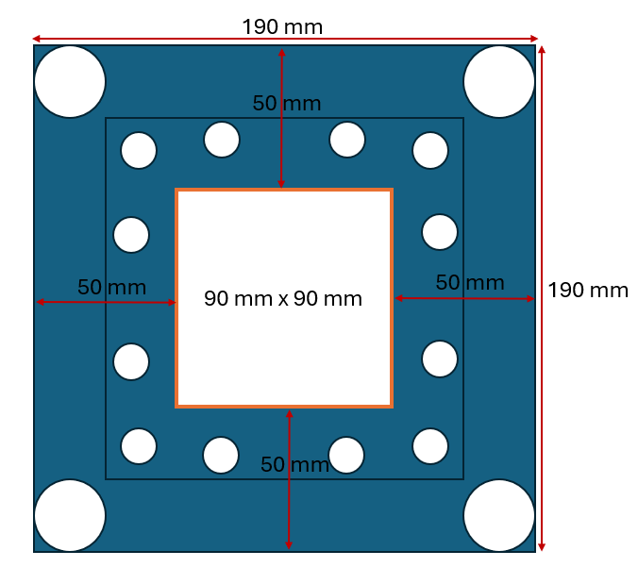
Figure 23: Jig dimensions [Wong, 2025]
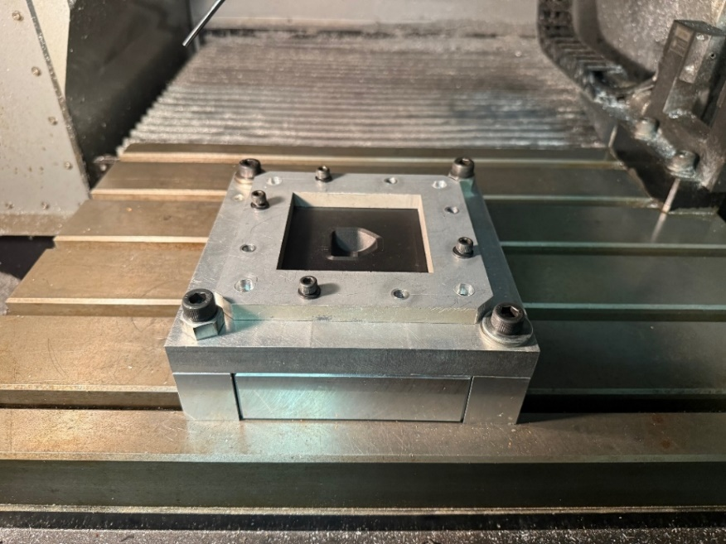
Figure 24: Jig Arrangement Outside of the Oil Bath [Wong, 2025]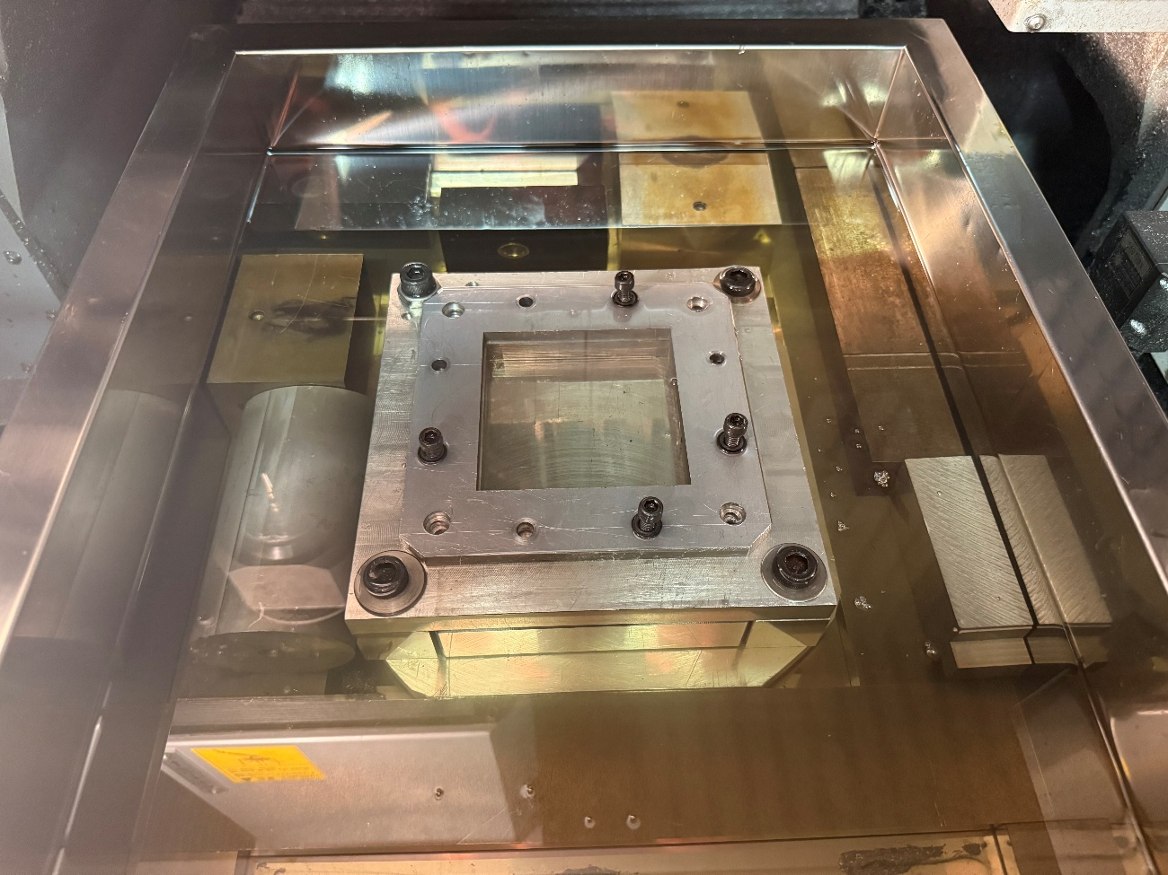
Figure 25: Jig Arrangement Inside an Oil Bath Configuration [Wong, 2025]

Test shape
To test the limits of the CAM system, the following test shape was run through the CAM system. This shape was selected as the test shape due to its greater complexity compared to the test shape used in previous research, as well as the constraints of the test materials, the physical limitations of the machining center, the machining tool, and the constraints of the type of incremental forming that is being conducted in this research.

Figure 26: Test Shape Used in the Experiment [Wong, 2025]

3.3 Experimental Setup and Procedure
To test the Toolpath generated by the CAM system, the test shape was designed in Creo 9.0 parametric and exported as an STL file. The experimental equipment described in the previous section was used. The Toolpath was generated by uploading the text file to a computer that is connected to the machining center via an Ethernet cable. The Toolpath is then loaded on the machining center and used during the experiment.
The oil bath is secured to the machining center, with the Jig attached to the bottom of the oil bath, as shown in Figure 26. Depending on the testing conditions in the experiments, the mold is inserted into the Jig, and the nylon sheet or CFRTP is secured to the Jig by the upper plate. After this, the temperature is set, and two of the four tests were completed at 120°C, while the other two were completed at 150°C. After the temperature reaches the target temperature, the Toolpath can be executed to machine the test shape.
The initial setup of the machining center, prior to experimentation, will be described in the appendix, as it is not relevant to the subsequent process.

3.4 Experimental Results

CAM System Comparison
When comparing the updated CAM system with the previous research's CAM system for complex shapes, the updated CAM system proves more effective in handling such shapes. The figures below compare the previous CAM system's toolpath with the updated CAM system's Toolpath for the updated test shape. The previous CAM system's Toolpath contains numerous extra points, which slow down the creation of the Toolpath and the machining process.
The updated CAM system creates the Toolpath with only the necessary points, optimizing both the shape detail and the time required to generate the Toolpath. When comparing the time it took to generate the Toolpath for the current test shape, the previous CAM system took approximately 2 hours and 30 minutes. In contrast, the current CAM system took approximately 2 seconds.

Incremental Forming Experiments
Due to the inability to effectively analyze the machined shapes using the 3D scanner. The only analysis that can be performed is the depth of the machined shape. During the tests, the experimental conditions from previous research served as a base to attempt to achieve the best results. The following four tests show the results from the experiments conducted for this research paper.
Table 6: Tests without a mold with nylon sheet.
Test Number | Feed Rate (mm/min) | Spindle Speed (RPM) | Forming depth (mm)
1 | 200 | 250 | 4.79
2 | 400 | 250 | 4.64
3 | 200 | 250 | 5.59
4 | 400 | 250 | 5.89
5 | 600 | 250 | 6.41
6 | 200 | 250 | 4.02
7 | 600 | 300 | 8.3
8 | 600 | 300 | 8.33
9 | 800 | 350 | 9.72
10 | 1000 | 500 | 9.16
Table 7: Tests with a mold with a nylon sheet.
Test Number | Feed Rate (mm/min) | Spindle Speed (RPM) | Forming depth (mm)
1 | 200 | 250 | 9.63
2 | 200 | 250 | 9.47
3 | 400 | 250 | 9.43
4 | 400 | 250 | 9.31
5 | 200 | 250 | 9.54
As mentioned in the section discussing the molds, the nylon sheet tests were used to verify whether the CAM system's Toolpath would work. From the two tables above, the toolpath was successfully formed with varying depths. The changes in feed rate and spindle speed were made to determine if the material thickness varied across different locations of the test shape. However, this did not seem to help, and the results were similar
Table 8: Tests with a mold with CFRTP.
Test Number | Feed Rate (mm/min) | Spindle Speed (RPM) | Temperature (Degrees C) | Forming depth (mm)
1 | 400 | 400 | 120
2 | 1000 | 500 | 120
3 | 1000 | 500 | 150
Table 9: Tests without a mold with CFRTP.
Test Number | Feed Rate (mm/min) | Spindle Speed (RPM) | Temperature (Degrees C) | Forming depth (mm)
1 | 1000 | 500 | 150
Due to time constraints, only four experiments were conducted with the CFRTP, as the cooling of oil and material took longer than expected. The first two tests of the CFRTP using a mold were unsuccessful due to the cooling period, as the test piece was removed before the oil bath and material were thoroughly cooled.

3.5 Evaluation
The changes made to the previous CAM system have enhanced the CAM system's ability to generate a toolpath for complex shapes without errors.

Chapter 4: Conclusion and Future Improvements
The changes to the CAM system have improved its ability to handle complex shapes, reducing toolpath generation time and machining time, and have improved the overall process from designing to manufacturing using incremental forming.
Some areas of improvement for this CAM system are mainly areas where the use of the CAM system can be more streamlined,
- Consolidating the variables so that the program can be changed to how the operator would like it.
- Having the program set the machining centers origin point for the workpiece automatically.
- Finding a way to improve strength of the formed shape as for the test shape when manufacturing using CFRTP the formed shape was weak
- A way to speed up the cycle of experiments as currently only one experiment using the oil bath can be conducted a day as the time it takes to cool the oil exceeds the time that the techno center is available to students.
A solution to decreasing the time it takes to reduce the experiment cycle is to use heat exchangers that are inserted into the oil after the experiment is completed and to cool the exchangers using a fan or air.

Appendix
Table A1: Sample of the Toolpath Data for Truncated Cone.
Coordinate Number | x | y | z
1 | 35.38074 | 16.98353 | 0
2 | -24.3741 | 8.981753 | 20.16743
3 | 13.69313 | 7.26465 | 35.19882
4 | -27.8541 | -19.5488 | 8.404538
5 | -30.4515 | 4.178701 | 0
6 | 3.737267 | -18.347 | 30.56381
7 | 11.69576 | 37.38804 | 1.108847
8 | -15.4359 | -31.4054 | 7.022253
9 | 7.207543 | -25.1519 | 0
10 | -18.2936 | -18.5911 | 19.88553
11 | 10.62484 | -32.4655 | 8.289417
12 | 2.843407 | -15.5052 | 34.86311
13 | 6.157133 | -29.6092 | 13.94509
14 | 21.27377 | 2.94206 | 26.57677
15 | -4.37845 | 20.54852 | 27.25231
16 | 2.544194 | 16.76084 | 33.12099
17 | -16.3648 | -7.26247 | 0
18 | 2.508552 | 22.63757 | 0
19 | -21.9715 | 18.83982 | 0
20 | -25.9499 | 29.48961 | 1.013605
21 | 2.603134 | -13.6337 | 0
22 | 18.75938 | 29.88954 | 0
23 | -12.8895 | -0.04869 | 39.00607
24 | -25.3572 | -8.68166 | 0
25 | -3.58629 | 27.33321 | 0
26 | 24.916 | 2.324154 | 21.41337
27 | 3.57487 | -9.04673 | 43.53424
28 | -13.7942 | -1.55114 | 0
29 | -32.3798 | 21.53292 | 1.478903
30 | -7.74691 | -30.0426 | 12.74601
31 | -10.1278 | -25.489 | 0
32 | -8.70421 | -14.0673 | 0
33 | 15.25032 | -29.5634 | 0
34 | -7.70801 | -37.0219 | 3.022466
35 | 25.47657 | -5.81376 | 19.83967
36 | 30.69521 | 6.550145 | 12.28288
37 | 15.57037 | -6.714 | 0
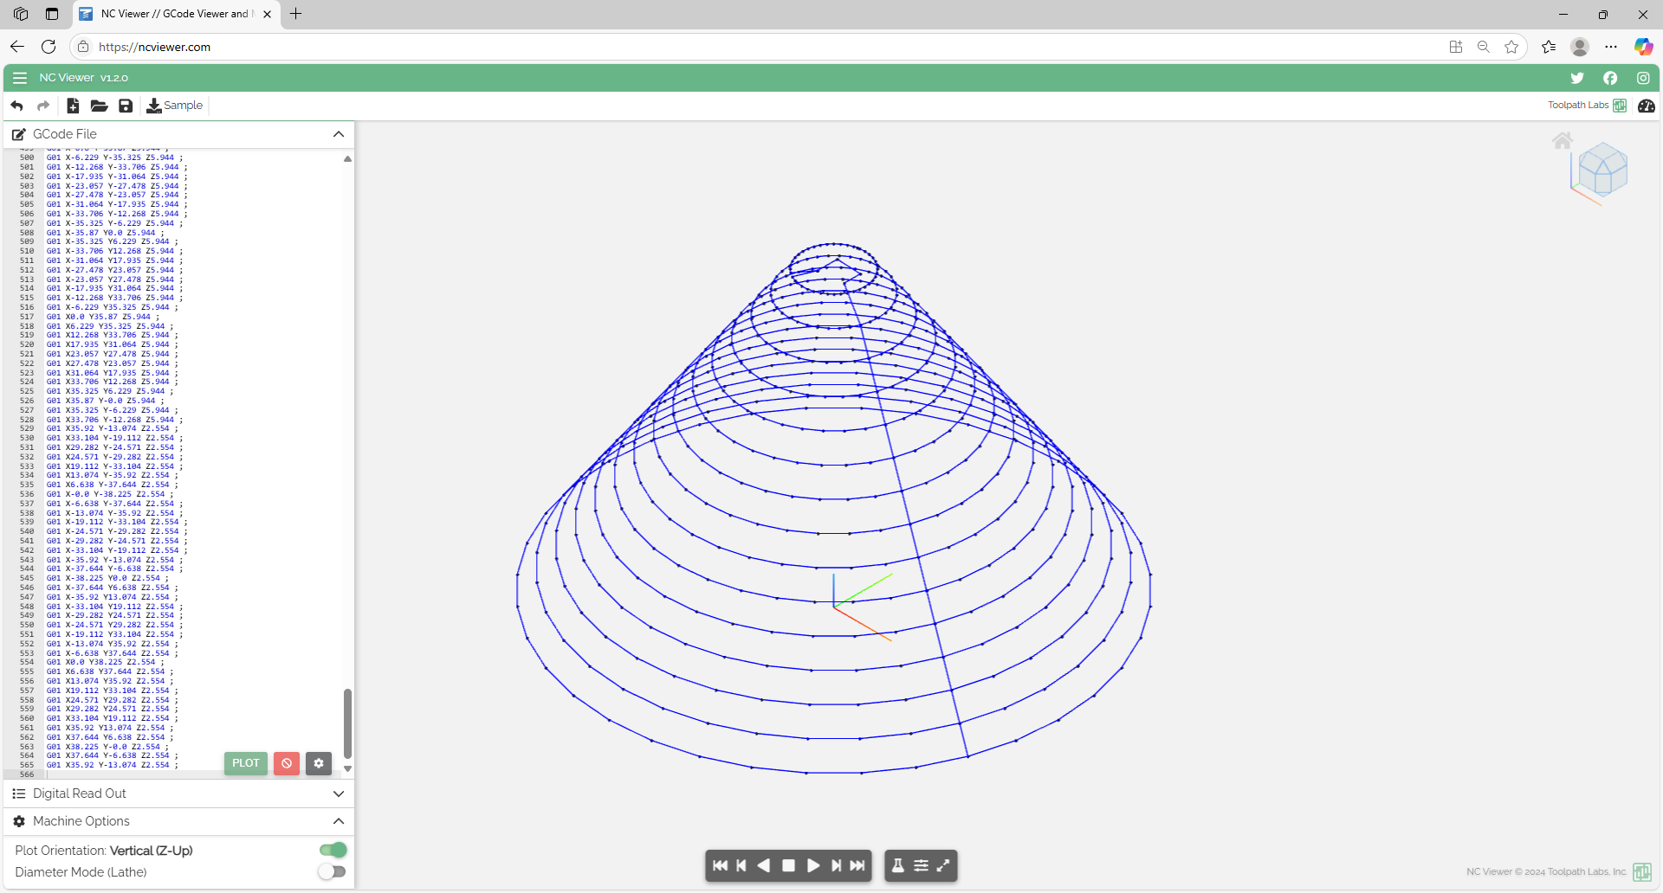
Figure A1: NC Viewer Screenshots of Toolpath Validation [Author, 2025].

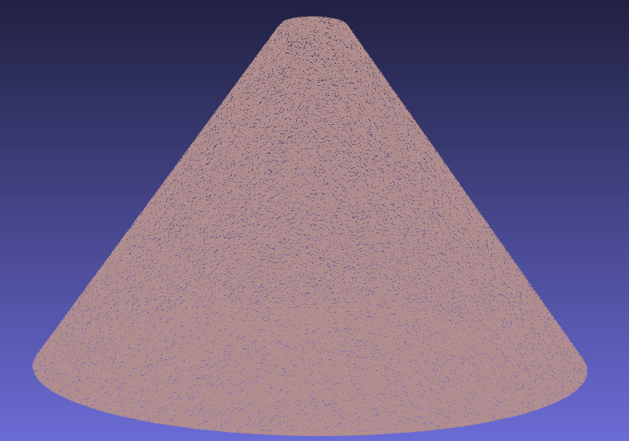
Figure A2: Point Cloud of the Truncated Cone [Author, 2025].

import pandas as pd
import numpy as np
from scipy.spatial import ConvexHull
from stl import mesh

# Configurable parameters
TOOL_DIAMETER = 3.4 # Tool diameter (mm)
Z_SPRINGBACK_OFFSET = -0.1
LAYER_THICKNESS = 1.0
MIN_DISTANCE = 0.5
Z_OFFSET = 50.5
SAFE_Z_RELATIVE = 50.0

# Load STL file and extract points
def load_stl_to_dataframe(stl_file, layer_thickness=1.0):
stl_mesh = mesh.Mesh.from_file(stl_file)
vertices = stl_mesh.vectors.reshape(-1, 3)
df = pd.DataFrame(vertices, columns=['x', 'y', 'z'])
df = df.drop_duplicates().reset_index(drop=True)
df['z'] = np.round(df['z'] / layer_thickness) * layer_thickness
return df.dropna()

# Filter close points to prevent clustering
def filter_close_points(points, min_distance=0.5):
filtered = [points[0]]
for p in points[1:]:
if np.linalg.norm(p - filtered[-1]) >= min_distance:
filtered.append(p)
return np.array(filtered)

# Sort points to prevent doubling back
def sort_points_no_overlap(points):
center = points.mean(axis=0)
angles = np.arctan2(points[:, 1] - center[1], points[:, 0] - center[0])
sorted_indices = np.argsort(angles)
sorted_points = points[sorted_indices]
n = len(sorted_points)
for i in range(n):
p1, p2 = sorted_points[i], sorted_points[(i + 1) % n]
for j in range(i + 2, n):
p3, p4 = sorted_points[j], sorted_points[(j + 1) % n]
if intersects(p1, p2, p3, p4):
sorted_points[i + 1:j + 1] = sorted_points[i + 1:j + 1][::-1]
return sorted_points

# Check if segments intersect
def intersects(p1, p2, p3, p4):
def ccw(A, B, C):
return (C[1] - A[1]) * (B[0] - A[0]) > (B[1] - A[1]) * (C[0] - A[0])
return ccw(p1, p3, p4) != ccw(p2, p3, p4) and ccw(p1, p2, p3) != ccw(p1, p2, p4)

# Smooth hull points
def smooth_hull_points(points, alpha=0.3):
smoothed = points.copy()
for i in range(len(points)):
prev = points[(i - 1) % len(points)]
next = points[(i + 1) % len(points)]
smoothed[i] = (1 - alpha) * points[i] + alpha * (prev + next) / 2
return smoothed

# Apply reverse offset using centroid-based method
def reverse_offset(points, TOOL_DIAMETER=2.5, z_springback_offset=-0.1):
adjusted_points = points.copy()
center = points[:, :2].mean(axis=0)
distances = np.linalg.norm(points[:, :2] - center, axis=1)
layer_radius = distances.max() if distances.size > 0 else 1.0
print(f"Layer at Z={points[0, 2]:.2f}, points={len(points)}, radius={layer_radius:.2f} mm, TOOL_DIAMETER={TOOL_DIAMETER:.2f} mm")
for i, point in enumerate(adjusted_points):
direction = point[:2] - center
norm = np.linalg.norm(direction)
if norm > 1e-6:
direction /= norm
offset = TOOL_DIAMETER * direction
adjusted_points[i, :2] -= offset
print(f"Point {i}: Offset applied = {offset[0]:.2f}, {offset[1]:.2f}")
adjusted_points[i, 2] += z_springback_offset
adjusted_points[:, :2] = smooth_hull_points(adjusted_points[:, :2])
x_min, x_max = adjusted_points[:, 0].min(), adjusted_points[:, 0].max()
y_min, y_max = adjusted_points[:, 1].min(), adjusted_points[:, 1].max()
adj_distances = np.linalg.norm(adjusted_points[:, :2] - center, axis=1)
adj_layer_radius = adj_distances.max() if adj_distances.size > 0 else 1.0
print(f"Adjusted radius={adj_layer_radius:.2f} mm")
print(f"Bounding box: X=[{x_min:.2f}, {x_max:.2f}], Y=[{y_min:.2f}, {y_max:.2f}]")
return adjusted_points

# Load reference toolpath from STL file
stl_file = 'test_piece_3.stl'
df = load_stl_to_dataframe(stl_file, layer_thickness=LAYER_THICKNESS)

# Main toolpath generation loop
ll = []
prev_exit_point = None
z_levels = sorted(df['z'].unique(), reverse=True)

# Calculate the desired uniform layer spacing
if len(z_levels) > 1:
z_diffs = [z_levels[i] - z_levels[i + 1] for i in range(len(z_levels) - 1)]
avg_spacing = np.mean(z_diffs)
print(f"Average layer spacing in input data: {avg_spacing:.3f} mm")
else:
avg_spacing = 1
print("Only one Z level in input data, using default spacing of 1 mm")

# Reassign Z levels to be uniformly spaced
uniform_z_levels = []
start_z = z_levels[0]
for i in range(len(z_levels)):
new_z = start_z - i * avg_spacing
uniform_z_levels.append(new_z)

# Calculate the center of the first layer for the initial move
center_x, center_y = None, None
for layer_idx, current_layer_z in enumerate(z_levels):
current_layer = df[df['z'] == current_layer_z][['x', 'y', 'z']].values
if len(current_layer) >= 5:
center_x, center_y = current_layer[:, :2].mean(axis=0)
break
if center_x is None or center_y is None:
print("Warning: Could not compute center from any layer. Using (0, 0) as fallback.")
center_x, center_y = 0.0, 0.0

# Process each layer with the new uniform Z levels
for layer_idx, current_layer_z in enumerate(z_levels):
current_layer = df[df['z'] == current_layer_z][['x', 'y', 'z']].values
if len(current_layer) < 5:
print(f"Skipping layer at Z={current_layer_z:.2f} due to insufficient points ({len(current_layer)})")
continue

layer_points_2d = current_layer[:, :2]
try:
hull = ConvexHull(layer_points_2d)
hull_coords = layer_points_2d[hull.vertices]
except Exception as e:
print(f"Skipping layer at Z={current_layer_z:.2f} due to hull error: {str(e)})")
continue

if hull_coords.shape[0] < 5:
print(f"Skipping layer at Z={current_layer_z:.6f} due to insufficient hull vertices ({hull_coords.shape[0]})")
continue

hull_coords = filter_close_points(hull_coords, min_distance=MIN_DISTANCE)

hull_z = np.full((hull_coords.shape[0], 1), uniform_z_levels[layer_idx])
hull_points_3d = np.hstack([hull_coords, hull_z])

adjusted_points_3d = reverse_offset(hull_points_3d, TOOL_DIAMETER=TOOL_DIAMETER, z_springback_offset=Z_SPRINGBACK_OFFSET)
adjusted_points_2d = adjusted_points_3d[:, :2]

sorted_points = sort_points_no_overlap(adjusted_points_2d)

# For the first layer, start at the point closest to the centroid
if layer_idx == 0:
centroid = np.array([center_x, center_y])
dists = np.linalg.norm(sorted_points - centroid, axis=1)
start_idx = np.argmin(dists)
sorted_points = np.roll(sorted_points, -start_idx, axis=0)
elif prev_exit_point is not None:
dists = np.linalg.norm(sorted_points - prev_exit_point[:2], axis=1)
start_idx = np.argmin(dists)
sorted_points = np.roll(sorted_points, -start_idx, axis=0)

sorted_layer = np.hstack([sorted_points, np.full((sorted_points.shape[0], 1), adjusted_points_3d[0, 2])])
layer_path = list(sorted_layer)
layer_path.append(layer_path[0]) # Close the loop
ll.extend(layer_path)
prev_exit_point = layer_path[0]

if len(ll) == 0:
print("Warning: No toolpath points generated. Check input data or layer filtering.")
exit()

# Apply Z offset to drop the Toolpath
ll = np.array(ll)
ll[:, 2] -= Z_OFFSET # Subtract z_offset from all Z coordinates

# Round toolpath coordinates to 2 decimal places
ll = np.round(ll, 2)

# Save Toolpath to CSV
pd.DataFrame(ll, columns=['x', 'y', 'z']).to_csv('toolpath.csv', index=False)

# Convert to G-code
df_ltp = pd.read_csv('toolpath.csv')

# Round coordinates to 2 decimal places and format explicitly
df_ltp['x'] = df_ltp['x'].round(2)
df_ltp['y'] = df_ltp['y'].round(2)
df_ltp['z'] = df_ltp['z'].round(2)

df_gchord = pd.DataFrame({
'G': 'G01',
'x': 'X' + df_ltp['x'].map('{:.2f}'.format),
'y': 'Y' + df_ltp['y'].map('{:.2f}'.format),
'z': 'Z' + df_ltp['z'].map('{:.2f}'.format),
'EOB': ';'
})

first_x = round(df_ltp.iloc[0]['x'], 2)
first_y = round(df_ltp.iloc[0]['y'], 2)
first_z = round(df_ltp.iloc[0]['z'], 2)

# Modified G-code header to start from the centroid
gcode_header = [
"G90 ; (Absolute positioning)",
"G21 ; (Set units to millimeters)",
"M03 ; (Start spindle)",
"S500 ; (Setting spindle speed)",
"F1000 ; (Set feedrate)",
f"G00 X{center_x:.2f} Y{center_y:.2f} ; (Rapid move to centroid)",
f "G01 Z{first_z:.2f} ; (Drop to first point's Z)",
f"G01 X{first_x:.2f} Y{first_y:.2f} ; (Move to first toolpath point)"
]

last_x = round(df_ltp.iloc[-1]['x'], 2)
last_y = round(df_ltp.iloc[-1]['y'], 2)

# Final safe Z is relative to the last point's Z position
last_z = df_ltp.iloc[-1]['z']
final_safe_z = last_z + SAFE_Z_RELATIVE

gcode_footer = [
f"G01 X{last_x:.2f} Y{last_y:.2f} Z{final_safe_z:.2f} ; (Retract tool to safe Z)",
"M30 ; (End of program)"
]

with open('Gchord.txt', 'w') as f:
for line in gcode_header:
f.write(line + '\n')
df_gchord.to_csv(f, index=False, sep=" ", header=False, mode='a')
for line in gcode_footer:
f.write(line + '\n')
Code A1: Complete Python CAM System Code [Author, 2025].
%pip install pandas
%pip install scipy
%pip install numpy-stl
Code A2: Libraries required to download
import pyvista as pv
import csv
import pandas as pd
import numpy as np

# Load STL file
mesh = pv.read('test_piece_3.stl')
points = mesh.points

# Export point cloud to CSV
with open('dots.csv', 'w') as f:
writer = csv.writer(f)
writer.writerows(points)

# Process point cloud
df = pd.read_csv('dots.csv')
df = df.dropna()
df = df.set_axis(['x', 'y', 'z'], axis='columns')
maxi = df['z'].max()
mini = df['z'].min()
df = df[df['z'] > mini + 0.01]
df.to_csv('dots.csv')
df = pd.read_csv('dots.csv')
ll = np.array([0, 0, 0])
pp = np.array([0, 0, 200])

# Toolpath generation loop
while len(df) > 0:
s = df['z'].max()
df_z = df[df['z'] == s]
df_z.to_csv('layer.csv')
df_z = pd.read_csv('layer.csv')
df_z = df_z.drop(df_z.columns[[0, 1]], axis=1)
df_z.to_csv('layer.csv')
l = np.loadtxt('layer.csv', delimiter=',', dtype='float64', skiprows=1, usecols=[1, 2, 3])
n = len(df_z)
c = 0
ltp = np.array([0, 0, 0])
if n > 1:
while n > 0:
ld = [np.linalg.norm(pp - l[j]) for j in range(n)]
k = ld.index(min(ld))
lk = l[k]
ltp = np.vstack([ltp, lk])
if c == 0:
llk = lk
l = np.delete(l, k, 0)
n -= 1
pp = lk
c += 1
ltp = np.delete(ltp, 0, 0)
ll = np.vstack([ll, ltp])
df = df[df['z'] < s]
ll = np.round(ll, 3)
with open('toolpath.csv', 'w') as f:
writer = csv.writer(f)
writer.writerows(ll)

# G-code conversion
df_ltp = pd.read_csv('toolpath.csv')
df_ltp = df_ltp.set_axis(['x', 'y', 'z'], axis='columns')
l = np.loadtxt('toolpath.csv', delimiter=',', dtype='float64', skiprows=1, usecols=[1, 2, 3])
lx, ly, lz = l[:, 0], l[:, 1], l[:, 2]
lx = ['X' + str(x) for x in lx]
ly = ['Y' + str(y) for y in ly]
lz = ['Z' + str(z) for z in lz]
df_gchord = pd.DataFrame({'G': 'G01', 'x': lx, 'y': ly, 'z': lz, 'EOB': ';'})
df_gchord.to_csv('Gchord.txt', index=False, sep=" ")
Code A3: Previous research’s CAM system
Starting the machine:
- Press the button to the left of the power button (the button has the word "source" written on it)
- Turn the mode to auto to ensure that the Toolpath can be run
- Please wait for the machine to output a large green button in the center of the screen with power written on it
- Press the power button that is next to the controller
- For the 3 x 3 origin point, the order of finding the origin is from top to bottom, and right to left is the priority of the origin setting.
- Go to "Files" from the menu bar at the bottom of the screen; grey boxes represent them.
- Select the middle gray button to select the "machine warm up (E25-sprun3M... )" NC code found in the files menu->HDD1 -> E25-sprun3M... (This process takes about 45 min to an hour)
- Do not forget to press the execute button (実行) that is in the bottom right corner of the screen. (you might need to navigate to find it)
- After sections seven and 7a, press the cycle start and wait 45 to an hour.
While the machine is warming up:
- Turn on the computer and select the profile that is in the middle
- The name is something like "pel2014," and the password is "pelpel."
- Double-click the "GCode" shortcut on the desktop
- Drag the code from the USB to that folder
Setting the origin for the tool:
- After the warmup process, must "zero" or find the origin concerning the Jig
- Ensure the "thicker tool" is attached; if not, follow the steps below. If it is already in, then skip to 10c.
- To do so, you must switch the tool out by pressing the tool switch button (near the bottom left of all the buttons)
- the tool will fall out, so be ready to catch it
- Using the manual adjustment and having the tool spin by pressing the sp cw button, have the tool touch the outer part of the Jig until the tool aligns
- Perform this step twice for both the X and Y directions to ensure the zero is accurate. Ensure that you press the "zeroing button" on the screen after every touch.
- To perform the "zeroing" for the Z direction, place the "green light" device on the material and slowly lower the tool until the light turns on. Then, raise the tool and repeat this process two more times.
- Ensure that you add 5 mm to the zeroing after the main Jig has been zeroed. This is to ensure room for error.
- After this, move to the center of the machine shape. (make sure to move the origin off by the amount that your tool will move on its initial movement for an offset. For example, if the first movement of the tool from the origin is to X 10 Y 10 Z 10, then offset the origin by X - 10 Y - 10 Z -10 so that the tool will make contact with the workpiece.)
- Please return to the machine, select the code, and let it run after the warmup is complete.
- Set the "Feed rate %" dial to 0 before executing to ensure it does not move too fast at start-up.
- "Cycle start" to start the program
Figure A3: Start-up procedures for the machining center.

Chapter 5: References
【1】 Bagherifard, S., Ghelichi, R., & Guagliano, M., "Shot peening: A review of the process and its applications," Journal of Materials Processing Technology, vol. 258, pp. 188–202, 2018.
【2】 Duflou, J. R., Habraken, A. M., Cao, J., Malhotra, R., Bambach, M., Adams, D., ... & Merklein, M., "Single point incremental forming: An assessment of the progress and technology trends from 2005 to 2015," Journal of Manufacturing Processes, vol. 28, no. 3, pp. 373–391, 2018.
【3】 Guttag, J. V., Introduction to computation and programming using Python, 3rd ed., The MIT Press, 2021.
【4】 Ikari, T., & Tanaka, H., "Feasibility study of laser-assisted incremental forming for carbon fiber reinforced thermoplastic based on 3D CAD data," Sophia University Technical Report, 2023.
【5】 Ikari, T., & Tanaka, H., "Feasibility study of single point incremental forming for discontinuous fiber CFRP using oil bath heating," Sophia University Technical Report, 2023.
【6】 Mitsumori, T., "Development of incremental forming techniques for automotive CFRP components," Sophia University Technical Report, 2023.
【7】 Sharma, V., Sharma, V., & Shukla, O. J., Principles and practices of CAD/CAM, Katson Books, 2014.
【8】 Shovic, J. C., & Simpson, A., Python all-in-one for dummies, Wiley, 2021.
【9】 Smid, P., CNC programming techniques, Industrial Press, 2006.
【10】 Tanata, H., "Carbon-fiber-reinforced-polymer manufacturing techniques," Sophia University Technical Report, 2023.
【11】 "Radiolucent Carbon Fiber–Reinforced Pedicle Screws for Treatment of Spinal Tumors: Advantages for Radiation Planning and Follow-Up Imaging," ScienceDirect. [オンライン]. Available: https://www.sciencedirect.com/science/article/abs/pii/S1878875017305971(最終閲覧日 2024/07/07)
【12】 "State of the Art in Incremental Forming," PMC. [オンライン]. Available: https://pmc.ncbi.nlm.nih.gov/articles/PMC11642863/ (最終閲覧日 2024/07/07)
【13】 "Incremental Forming," ScienceDirect. [オンライン]. Available: https://www.sciencedirect.com/topics/engineering/incremental-forming (最終閲覧日 2024/07/07)
【14】 "The technology of Incremental Sheet Forming—A brief review of the history," ScienceDirect. [オンライン]. Available: https://www.sciencedirect.com/science/article/pii/S092401361000028X (最終閲覧日 2024/07/07)
【15】 Bachmann, J., Hidalgo, C., & Bricout, S., "Environmental analysis of innovative sustainable composites with potential use in aviation sector—A life cycle assessment review," Science China Technological Sciences, vol. 60, pp. 1301–1317, 2017.
【16】 "Product Page for 61-3235-86," Axel Global. [オンライン]. Available: https://www.axel-gl.com/en/asone/d/61-3235-86/ (最終閲覧日 2024/07/07)

